Meeting Minutes 8/31/2025

Attendees:
Corey Burgos
Elijah Cesaire
Aaron Harrison
Daniel Pynas
Bryson Rusomaroff
Dustin Locke
David Smith
Krishna Good – Scribe

Discussion:
Project Idea, what we want to work on, how we want to implement, front end options
Application scope, target users, core features.

Action Items:
- Miro Board – create user stories
- Initial project proposal – create a proposal for Capstone project
  - Assign temporary roles
Environmental Description:
Discord
Microsoft Word
Miro
VS Code
IntelliJ
Angular
Postgres

Meeting Minutes 9/10/2025

Attendees:
Corey Burgos
Elijah Cesaire
Aaron Harrison
Daniel Pynas
Bryson Rusomaroff
Dustin Locke
David Smith
Krishna Good – Scribe

Discussion:
User stories, Core features, Final Project proposal
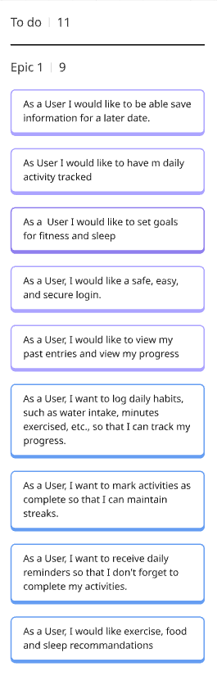

Action Items:
- Review final proposal
- Being working on repo
- Begin working Diagrams
Environmental Description:
Discord
Microsoft Word
Miro

Meeting Minutes 9/14/2025

Attendees:
Corey Burgos
Elijah Cesaire
Aaron Harrison
Bryson Rusomaroff
Dustin Locke
David Smith
Krishna Good – Scribe

Discussion:
System Design Phase 1 Documents, Repo setup, ER diagram, system architecture, UI wireframes/mockups

Action Items:
- Entity Relationship diagram
- UI wireframes (Storyboard)

Environmental Description:
Discord
Microsoft Word
Miro
Microsoft Visual Studio
Microsoft Visio
Java Spring Boot
Angular

Meeting Minutes 9/21/2025

Attendees:
Corey Burgos
Elijah Cesaire
Aaron Harrison
Dustin Locke
David Smith
Daniel Pynas
Krishna Good – Scribe

Discussion:
Module 3 Milestone Deliverables, assigning duties

Action Items:
- Entity Relationship diagram – Dustin
- UI wireframes (Storyboard) – Corey
- API Specification Draft – Elijah
- System Architecture overview - Dustin

Environmental Description:
Discord
Microsoft Word
Miro
Microsoft Visual Studio
Lucid Chart
Java Spring Boot
Angular

Meeting Minutes 9/28/2025

Attendees:
Corey Burgos
Bryson Rusomaroff
Elijah Cesaire
Aaron Harrison
Dustin Locke
David Smith
Krishna Good – Scribe

Discussion:
Module 3 Milestone Deliverables completed
- System Architecture Overview – Dustin Locke
- Preliminary Data Model – Dustin Locke
- API Specification draft – Elijah Cesaire
- UI Wireframes/Storyboard – Corey Burgos
Module 4 Milestone Deliverables TBD
- Data Model
- API specs
- Initial frontend component stubs
Action Items:
- Data Model
- API specs
- Initial frontend component stubs

Environmental Description:
Discord
Microsoft Word
Miro
Microsoft Visual Studio
Lucid Chart
Java Spring Boot
Angular

Meeting Minutes 10/05/2025

Attendees:
Corey Burgos
Bryson Rusomaroff
Elijah Cesaire
Aaron Harrison
Dustin Locke
David Smith
Krishna Good – Scribe

Discussion:
Module 4 Milestone Deliverables
- Data Model
- API specs
- Initial frontend component stubs
Began working on backend components – Dustin Locke
Action Items:
Data Model – Dustin Locke
API specs – Aaron Harrison
Initial frontend component stubs – David Smith

Environmental Description:
Discord
Microsoft Word
Miro
Microsoft Visual Studio
Lucid Chart
Java Spring Boot
Angular

Meeting Minutes 10/12/2025

Attendees:
Corey Burgos
Elijah Cesaire
Dustin Locke
David Smith
Krishna Good – Scribe

Discussion:
Module 4 Deliverables
  - Aaron Harrison
    - Created Detailed API Specification documentation
  - Bryson Rusomaroff
    - UI Design and Navigation Flow
  - David Smith
    - Developed test codes for API’s
  - Dustin Locke
    - Created Finalized Data Model Diagram
  - Elijah Cesaire
    - Created Refined System Architecture Overview documentation

Action Items:
Finish Data model
Finish System Architecture Overview
Finish Implementation Readiness Plan
Update ReadMe
Environmental Description:
Discord
Microsoft Word
Miro
Microsoft Visual Studio
Lucid Chart
Java Spring Boot
Angular
GitHub

